

**IE143P LABORATORY EXPERIMENT**

**Activity No. 4: Encoding Specificity**

Name: Raven Bajar Date: 01/07/22

**DISCUSSION**

According to the encoding specificity principle (Tulving, 1983) the recollection of an event depends on the interaction between the properties of the encoded event and the properties of the encoded retrieval information. In other words, whether an item will be remembered at a particular time depends on the interaction between the processing that occurred during encoding and the processing that occurred at retrieval.

As an example, think of a list of words presented for a later memory test. One of the target words is bank paired with dollar. You think of a place where you store money. At test, you are asked if bank was on the list, but bank is now paired with river. You are likely to say that bank was not on the list. This is an extreme example, in which the target has two different meanings. However, you can observe the same result with subtler changes in how an item is processed.

This principle has important implications for what you can say about memory. Because it is the interaction of both encoding and retrieval that is important, it means that you cannot make any statement about the mnemonic properties of an item or a type of processing or a cue unless you specify both the encoding and the retrieval conditions (Tulving, 1983). Thus, you cannot say things like:

* recognition is easier than recall
* deep processing is better than shallow processing
* pictures are recalled better than words

The reason is that how an item is encoded at test can affect whether it is remembered at test. It is easy to set up a situation in which a change in processing at encoding produces results that lets you conclude that:

* recall is easier than recognition (Watkins & Tulving, 1975)
* shallow processing is better than deep processing (Morris, Bransford, & Franks (1977)
* words are recalled better than pictures (Weldon & Roediger, 1988)

This demo is loosely based on Thomson and Tulving (1970). At study, you will see a pair of words, one in lowercase (the cue) and one in uppercase (the target). Read both words to yourself. At test, you will also see a pair of words. Your task is to decide whether you saw the uppercase word during the study phase.

**ADMINISTRATION TIME**

Around 35 minutes, depending on level of impairment.

##### INSTRUCTIONS

##### You need to access “CogLab: The Online Cognition Lab” via website and log in to the account. Log in details will be provided by your instructor.

If you have logged in, you'll see a rectangle below. Make sure that you can see the full area before you begin the lab.

There are two parts to this lab.

In Phase I, you will see a pair of words, one in lowercase (the cue) and one in uppercase (the target). Read the words silently to yourself. There are 48 pairs of words.

In Phase II, you will again see a pair of words, one in lowercase (the cue) and one in uppercase (the target). Your task is to judge if the target (the word in uppercase) was shown in Phase I. It doesn't matter if the cue is the same or different from Phase I, the judgment is always whether the uppercase word was in Phase I. There are 96 word pairs shown in Phase II.

At the end of the experiment, you will be asked if you want to save your data to a set of global data. After you answer the question, a new Web page window will appear that includes a debriefing, your data, your group's data, and the global data.

**TABLET SPECIFIC DETAILS**

If you are using a tablet, tap the Start Next Trial button to begin. In Phase II, tap on the Yes button if the uppercase word was in Phase I, and tap on the No button if the uppercase word was not in Phase I.

### **COMPUTER SPECIFIC DETAILS**

If you are using a computer, click the Start Next Trial button to begin. In Phase II, click on the Yes button if the uppercase word was in Phase I, and click on the No button if the uppercase word was not in Phase I.

##### OUTCOME MEASURES

The outcome measures for Encoding Specificity Experiment covers the proportion correct for each study/test cue. There were two parts of the experiment. In Phase I you will see a pair of words, one in lowercase (cue) and one in uppercase (target). In Phase II, you were again shown a pair of words. Your task was to decide if the word shown in the uppercase was one of the words previously shown in uppercase in Phase I.

The independent variable in this experiment was the type of cue at study and the type of cue at test (either weak or strong). The dependent variable was the proportion of times you correctly judged that the test probe was on the list.

The designations 'weak' and 'strong' for the cues are used only to indicate pre-existing strength of the cue to elicit the target. For example, "fruit" is a weak cue for "flower" because when you ask people to say the first word that pops into their head when they hear this cue, it is rarely "flower". In contrast, "bloom" is a strong cue for flower; people frequently respond "flower" after hearing the word "bloom".

The 'lure' items are there because we used a recognition test and needed to present some items that had not been seen before.

**SUMMARY DATA**

|  |  |
| --- | --- |
| **STUDY/TEST CUE** | **PROPORTION CORRECT** |
| Weak/Weak | 0.917 |
| Weak/Strong | 0.667 |
| Strong/Weak | 0.667 |
| Strong/Strong | 1.000 |
| Lure | 0.771 |

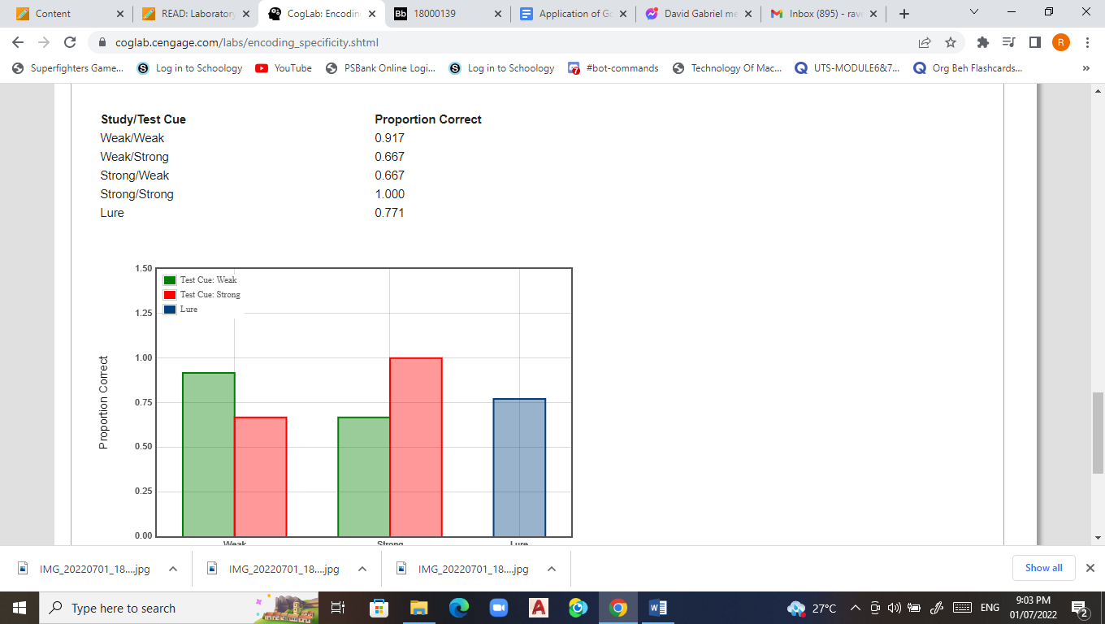

**DATA ANALYSIS**

1. Based on the results of the experiment, at which study/test cue did you perform better? How do you explain your observation?

Based on the result and my observation, I performed better when the cue is both strong or has both strong relationship which according to the data I got a 1.000. Based on the experiment, I had troubled identifying whether the uppercase words are in phase 1 when it is paired with a weak cue. I observed that, having a strong cue or relationship to the other word has a positive effect in your memory and can help your mind to remember and recognized the word faster and have a better overall memory.

1. How do your results compare with the results from global data? Use statistical analysis (1 Sample T-Test) to compare your results from global data.

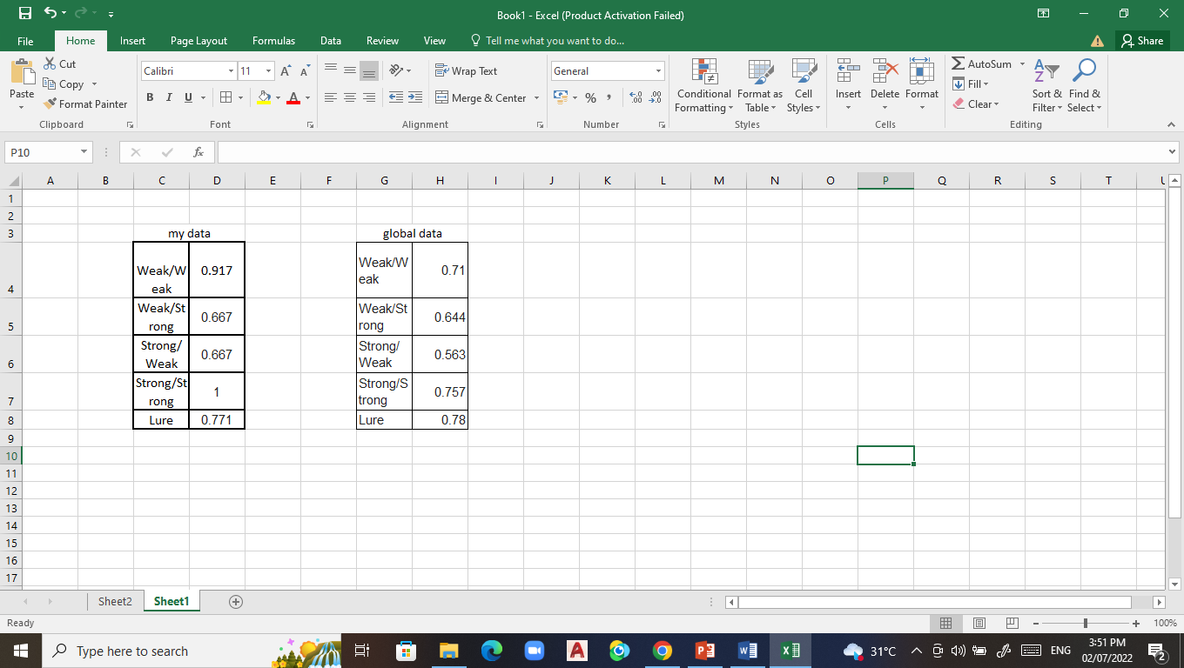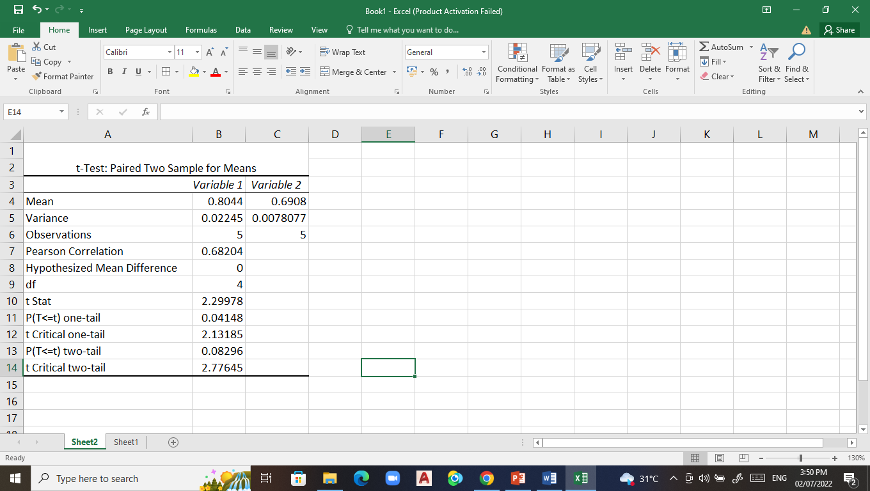

1. Are there significant relationships in recalling words based on the type of cue at study/test cue used in the experiment? Use statistical analysis (Correlation Analysis) to determine the relationship between proportion of times you correctly judged that the test probe was on the list (dependent variable) and the type of cue at study / test cue (independent variable). Use the following legend to perform the correlation analysis: 0-lure, 1-weak/weak, 2-weak/strong, 3-strong/weak, 4-strong/strong

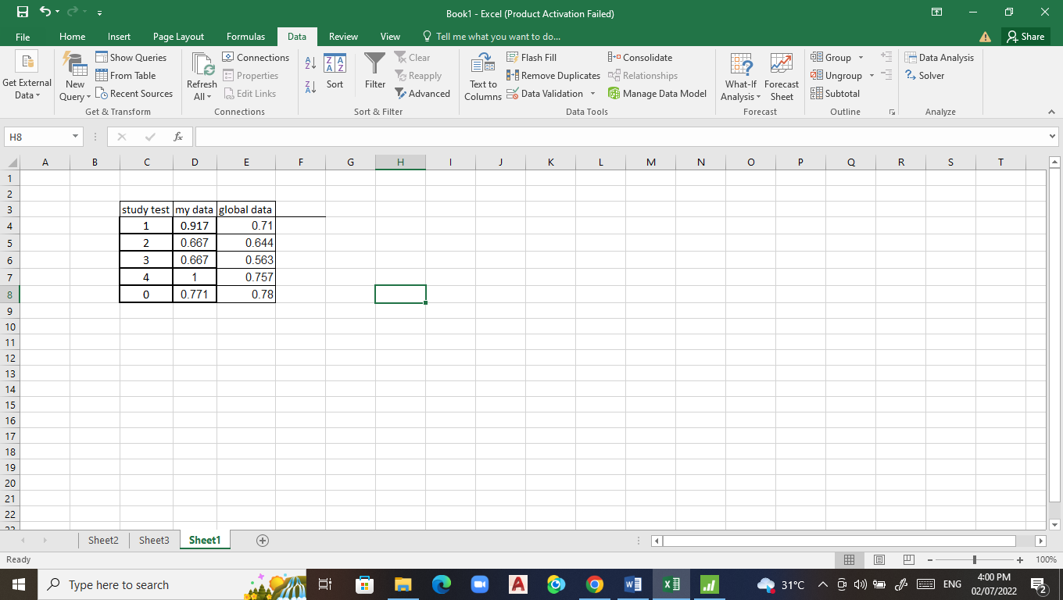

1. According to the encoding specificity principle, what is the most important factor for recall? Explain you answer.

The semantic strength of the retrieval cue is the most important factor for recalling because it allows you to access memories stored in long-term memory and send them to your conscious awareness thus can make it easier to recall memories and remember memories stored deep in your brain. Because retrieval cue helps and assist in memory retrieval, it allows us to remember easier and quickly by the help of the retrieval cue.

1. Do cues always help memory study and recall? Explain your answer.

Yes, because in relation to the experiment, it helps your mind to remember and recall the words in phase 1 to phase 2. A strong cue has a higher chance of you recalling the word but in a weak cue the chances are lowered but can still help in remembering and enhancing your memory. A cue is a somewhat a hint or clue for you to answer the problem or remember the word in relation to the experiment.

**REFERENCES**

*Morris, C. D., Bransford, J. D., & Franks, J. J. (1977). Levels of processing versus transfer appropriate processing. Journal of Verbal Learning and Verbal Behavior, 16, 519–533*

*Nairne, J. S. (2002). The myth of the encoding-retrieval match. Memory, 10, 389-395.*

*Tulving, E. (1983). Elements of episodic memory. New York: Oxford.*

*Watkins, M. J., & Tulving, E. (1975). Episodic memory: When recognition fails. Journal of Experimental Psychology: General, 104, 5–29.*

*Weldon, M. S., & Roediger, H. L. III. (1988). Altering retrieval demands reverses the picture superiority effect. Memory & Cognition, 15, 269-280.*